Department of Computer Science and Engineering / Information Technology
MIT SCHOOL OF COMPUTING
MIT ADT University, Loni Kalbhor, Pune

Instructions for B.Tech. Project Report Writing
- Project Report should include necessary certificates, acknowledgment, tables, list of diagrams, abstract, annexure (i.e., Paper), index.(pages from 60 to 90)
- If particular part is repeated, you can mention “Refer Page No. and point” or “Refer Annex
- Prepare at least n + 2 Project Report copies of your manuscripts for student, Guide, Department, University/Library. Submit soft copy in CD.
- Acknowledgment, List of Publications, List of Diagrams, List of Tables, Abstract should have page nos I, II, III, IV respectively.
- Always place the images/Diagrams/Table at the beginning or end of the page.
- The footer “MITSOC, Department of Computer Engineering <year YYYY>” should be included. (10, Times Roman, Center justified) from Introduction page
- Main part of manuscripts should be Times Roman, 12 pts, justified and 1.5 line spacing(Should be Printed on both side of paper)
- Use paper size 8.5” x 11” or A4 (210 x 197 mm). Follow following margins.
Margin | Paper A4 | Margin | Paper A4
Top | 1” | Bottom | 1
Left | 1.25 | Right | 1 “
All paragraphs will be single line spaced with a 1.5 line space between each paragraph. Each paragraph will begin with a two-space indentation.
- Chapter titles should be bold with 18 pt typed in all CAPITALS letters and should be aligning at the center of the page.
- Section heading should be aligning at the left with 12 pt and bold and capitalized.
- Section subheading should be aligning at the left with title case.
- Leave one spaces between section heading and 10 pt space between two-section subheadings.
- References should be in IEEE format, in the order as they appear in the dissertation.
- Symbols and notations if any should be included in nomenclature section only.
- All chapters, section heading and sub headings should be numbered. For chapter use numbers 1,2,3 and for sub headings 1.1, 1.2, 1.3. And section subheadings 2.1.1, 2.1.2 etc.
The text should be typed on both side of the paper.

A PROJECT REPORT ON

Automating the Detection of Profanity and Abusive Language in Audio Conversations Using Speech-to-Text and AI-Based Classification Models

SUBMITTED TO
MIT SCHOOL OF COMPUTING, LONI, PUNE IN PARTIAL FULFILLMENT OF THE REQUIREMENTS FOR THE AWARD OF THE DEGREE

BACHELOR OF TECHNOLOGY
(Computer Science & Engineering/ Information Technology)

BY

Reejit Adhikary ADT23SOCB0844
Vansh Chaudhari ADT23SOCB1262
Vedang Hirave ADT23SOCB1278
Tanishq Jhade ADT23SOCB1208

Under the guidance of

Prof Manoj Shinde



DEPARTMENT OF COMPUTER SCIENCE AND ENGINEERING

MIT School OF COMPUTING
MIT Art, Design and Technology University
Rajbaug Campus, Loni-Kalbhor, Pune 412201

2025- 26


MIT SCHOOL OF COMPUTING
DEPARTMENT OF COMPUTER SCIENCE AND ENGINEERING
MIT ART, DESIGN AND TECHNOLOGY UNIVERSITY,
RAJBAUG CAMPUS, LONI-KALBHOR, PUNE 412201

CERTIFICATE

This is to certify that the project report entitled
“Automating the Detection of Profanity and Abusive Language in Audio Conversations Using Speech-to-Text and AI-Based Classification Models”

Submitted by

Reejit Adhikary ADT23SOCB0844
Vansh Chaudhari ADT23SOCB1262
Vedang Hirave ADT23SOCB1278
Tanishq Jhade ADT23SOCB1208

is a bonafide work carried out by them under the supervision of Prof.Manoj Shinde and it is submitted towards the partial fulfillment of the requirement of MIT ADT university, Pune for the award of the degree of Bachelor of Technology (Computer Science and Engineering) (12, Sentence case)

Prof. Manoj Shinde Prof. Dr. Jayshree Prasad
Guide Head of Department

Prof. Suresh Kapare Dr. Ganesh Pathak
Chief Coordinator-PBL Dean

Seal/Stamp of the College
Place: PUNE
Date:05-11-2025

On Company Letter head/seal

CERTIFICATE

This is to certify that the Project report entitled

“Automating the Detection of Profanity and Abusive Language in Audio Conversations”

Submitted by

Reejit Adhikary ADT23SOCB0844
Vansh Chaudhari ADT23SOCB1262
Vedang Hirave ADT23SOCB1278
Tanishq Jhade ADT23SOCB1208

is a bonafide work carried out by him/her (with the Sponsorship from ------------) under the supervision of Mr Manoj Shinde and has been completed successfully.

(Mr. ……………… )
(Designation)
External Guide
(12, Sentence case) Seal/Stamp of the Company/College

Place :
Date :

DECLARATION

We, the team members

Name | Enrollment No
Reejit Adhikary | ADT23SOCB0844
Vansh Chaudhari | ADT23SOCB1262
Vedang Hirave | ADT23SOCB1278
Tanishq Jhade | ADT23SOCB1208

Hereby declare that the project work incorporated in the present project entitled “Automating the Detection of Profanity and Abusive Language in Audio Conversations” is original work. This work (in part or in full) has not been submitted to any University for the award or a Degree or a Diploma. We have properly acknowledged the material collected from secondary sources wherever required. We solely own the responsibility for the originality of the entire content.

Date: 05/11/2025
Name & Signature of the Team Members
Reejit Adhikary: __________________
Vansh Chaudhari: __________________
Vedang Hirave: __________________
Tanishq Jhade: __________________

Name and Signature of Guide

Seal/Stamp of the College
Place: Pune
Date: 05/11/2025


DEPARTMENT OF COMPUTER SCIENCE & ENGINEERING
MIT SCHOOL OF COMPUTING,
RAJBAUG, LONI KALBHOR,
PUNE – 412201

EXAMINER’S APPROVAL CERTIFICATE

The project report entitled “Automating the detection of Profanity and Abusive Language in Audio Conversations” submitted by Reejit Adhikary (ADT23SOCB0844), Vansh Chaudhari (ADT23SOCB1262), Vedang Hirave (ADT23SOCB1278), Tanishq Jhade (ADT23SOCB1208) in partial fulfillment for the award of the degree of Bachelor of Technology (Computer Science & Engineering) during the academic year 2021-22, of MIT-ADT University, MIT School OF COMPUTING, Pune, is hereby approved.

Examiners:

1.

2.

ACKNOWLEDGEMENT

We would like to express my heartfelt gratitude to all those who have contributed to the successful completion of this project.First and foremost, We extend my sincere thanks to Prof. Manoj Shinde, for his constant guidance, valuable suggestions, and continuous encouragement throughout the course of this work. Their support and insightful feedback have been instrumental in shaping this project.We are also deeply thankful to MIT SCHOOL OF COMPUTING for providing the necessary facilities and resources to carry out this project successfully.This project, which focuses on the automation of detecting profanity and abusive language in audio-based human interactions, has been a challenging yet rewarding experience. It involved integrating speech recognition, natural language processing, and machine learning models to build a system capable of identifying offensive content in real-time. Through this process, I gained extensive knowledge in fields such as audio signal processing, deep learning architectures, and ethical AI applications, which greatly enhanced my technical and research skills. It would not have been possible without the collective effort and support of all the above individuals.

Reejit Adhikary, ADT23SOCB0844
Vansh Chaudhari,ADT23SOCB1262
Vedang Hirave,ADT23SOCB1278
Tanishq Jhade,ADT23SOCB1208

ABSTRACT

This project aims to develop an automated system that can detect profanity and abusive language in audio conversations using artificial intelligence. The system converts speech to text using advanced models like Whisper and Wav2Vec2, and then analyzes the transcribed text using NLP-based classification models such as BERT and LSTM. The process involves audio preprocessing, transcription, text cleaning, and classification to identify offensive or inappropriate language. The proposed model achieves high accuracy even with different accents and background noise. Experimental results show that the BERT and Whisper combination provides better performance, achieving around 93% accuracy in detecting abusive content. This system can be useful for maintaining safe and respectful communication across online platforms, gaming chats, and virtual meetings.

CONTENTS

Certificate ………………....………………………….…………. | 1
Declaration ……………….…………….………………....………. | 3
Examiner’s Approval Certificate …………………………………. | 4
Acknowledgement ……………….…………………..……………. | 5
Abstract …………………………………………..…...……………. | 6
List of Figures ………………………..………….…………………. | 9
List of Tables ……………………….…………….…………………. | 9

Chapter 1 INTRODUCTION 10
1. Introduction 1
1.1 Digitalization in Labor Market: 2
2. Existing Work 3
3. Motivation 3
4. Objectives 4
5. Scope 4
Chapter 2 CONCEPTS AND METHODS 5
2.1 definitions 5
Chapter 3 LITERATURE SURVEY 7
Chapter 4 PROJECT PLAN 10
Chapter 5 SOFTWARE REQUIREMENT SPECIFICATION 24
5.1 Project scope 24
5.2 User Classes & Characteristics Coder 25
Chapter 6 RESULTS 26
Chapter 7 SOFTWARE TESTING 28
Chapter 8 CONCLUSION AND FUTURE WORK 31
BIBLIOGRAPHY 32
ANNEXURE A: List of Publications and Research Paper (In its Original formats) 16
ANNEXURE B: Plagiarism Report 17

LIST OF FIGURES

Figure Number: Figure of the table Page Number

Figure 2.1: System Architecture 17
Figure 6.1: Frontend Model 26
FIGURE 6.2: Working 27

LIST OF TABLES

Table Number: Title of the table Page Number

Table 4.1 Tools and Categories 25
Table 7.1: Types of testing Performed 28
Table 7.2: Test Cases(Sample) 29
Table 7.3: Bug Report Summary 30

CHAPTER 1 INTRODUCTION

1.1 Introduction
In recent years, the use of audio-based communication has grown rapidly across various platforms such as online gaming, social media, customer service calls, and virtual meetings. While these technologies have made global communication more accessible and convenient, they have also introduced new challenges related to digital behavior and language use. Verbal abuse, hate speech, and offensive language are increasingly common in online spaces, often resulting in negative psychological impacts and toxic environments for users. Manual monitoring or moderation of such conversations is neither scalable nor efficient, which highlights the need for automated systems capable of identifying and filtering abusive language in real time.
The proposed project, “Automating the Detection of Profanity and Abusive Language in Audio Conversations Using Speech-to-Text and AI-Based Classification Models,” addresses this challenge by combining speech recognition and natural language processing (NLP) technologies. The system first converts spoken audio into text using speech-to-text models such as Whisper or Wav2Vec2 and then processes the text through AI-based classification models like BERT and LSTM. These models help the system understand the context and semantics of the conversation, ensuring accurate detection of offensive or inappropriate language.

2. Existing Work
Several studies and systems have explored offensive language detection in text-based formats. For example, Davidson et al. (2017) introduced a dataset for hate speech and offensive language detection on Twitter, and Google’s Jigsaw project developed the Toxic Comment Classification dataset, which has been widely used for text-based moderation tasks. WhileTo design and implement an AI-based system these models perform well on textual data, they fail to handle the complexities of spoken communication such as tone, emotion, and background noise.
In the field of speech-based analysis, new frameworks like MuTox (ACL 2024) have demonstrated promising results in multilingual audio toxicity detection. Similarly, OpenAI’s Whisper and Meta’s Wav2Vec2.0 have improved speech recognition accuracy even under noisy conditions, paving the way for real-time moderation tools. However, very few integrated systems combine both automatic speech recognition (ASR) and deep learning-based text classification for profanity detection. This project builds upon these advancements to create a unified and efficient framework for analyzing audio conversations.

3. Motivation

The primary motivation for this project is the growing concern over abusive and offensive behavior in online communication platforms. Exposure to verbal abuse can lead to emotional distress, harassment, and the deterioration of healthy online communities. Platforms such as gaming voice chats, social media live streams, and customer service interactions require real-time monitoring tools to prevent such incidents.

Developing an AI-based system capable of automatically identifying and flagging offensive speech not only helps in maintaining a respectful communication environment but also reduces the burden on human moderators. Additionally, the project offers an opportunity to explore advanced AI and NLP techniques, contributing to the broader field of ethical AI and digital safety.

4. Objectives
The main objectives of this project are as follows:
- that can automatically detect profanity and abusive language from audio inputs.
- To integrate speech-to-text technology for accurate transcription of spoken language.
- To apply NLP and deep learning models such as BERT and LSTM for contextual classification of text.
- To evaluate model performance based on parameters like accuracy, F1-score, and precision.
- To enhance digital communication safety by enabling automated moderation of voice-based conversations.
- To ensure scalability and robustness across different accents, noise conditions, and multilingual scenarios.

5 .Scope
The scope of this project includes the development and evaluation of a complete pipeline for detecting profanity and abusive language from audio inputs. The system covers:
- Audio preprocessing: Filtering background noise and segmenting speech.
- Speech-to-text conversion: Transcribing spoken language into text using ASR models.
- Text classification: Identifying offensive or toxic content using machine learning and NLP models.
- Evaluation: Measuring accuracy, F1-score, and precision of various model combinations.
The project currently focuses on English and Hindi audio datasets but can be extended to other languages. It is designed for applications such as online gaming moderation, video conferencing tools, and social media platforms that require real-time or post-conversation analysis

CHAPTER 2 CONCEPTS AND METHODS
Figure STYLEREF 1 \s 2. SEQ Figure \* ARABIC \s 1 1: This is my First Figure

2.1 Concept
The main concept of this project is to automate the detection of profanity and abusive language in spoken conversations using artificial intelligence (AI). The system converts spoken audio into text using Speech-to-Text (STT) technology and then applies Natural Language Processing (NLP) and machine learning (ML) models to analyze the transcribed text for offensive or toxic content.
Traditional content moderation systems rely heavily on manual monitoring or text-only detection, which is inefficient and limited in handling audio inputs. This project bridges that gap by integrating speech recognition with context-aware language models, allowing the detection of abusive language directly from real-time audio streams.
The system operates through a structured pipeline consisting of the following stages:
- Audio Preprocessing: Cleaning and segmenting audio input.
- Speech-to-Text Conversion: Transcribing spoken words into textual format.
- Text Preprocessing: Normalizing and preparing text for analysis.
- AI-Based Text Classification: Detecting profanity and abusive expressions using NLP and deep learning models.
- Output Generation: Producing a toxicity score or label to classify the conversation as clean, offensive, or abusive.
This combination of acoustic processing and semantic understanding allows for real-time, scalable, and multilingual moderation of digital communications.

2.2 Methods Applied
The project involves several interconnected AI and NLP methods, each responsible for a specific function within the pipeline. The following subsections define and describe the key techniques used.

2.2.1 Audio Preprocessing
Definition:
Audio preprocessing refers to the process of improving the quality of an audio signal before further analysis. It involves removing noise, normalizing volume, and segmenting speech into smaller portions for easier processing.
Methods Used:
- Noise Reduction: Removes unwanted background sounds using filters or spectral subtraction.
- Segmentation: Divides continuous audio into smaller speech segments.
- Silence Removal: Eliminates long pauses to reduce processing time.
Purpose:
These steps ensure that only clear and relevant speech is passed to the transcription module, improving the accuracy of the Speech-to-Text model.

2.2.2 Speech-to-Text (STT) Conversion
Definition:
Speech-to-Text (STT), also known as Automatic Speech Recognition (ASR), is the technology that converts spoken language into written text using machine learning algorithms.
Models Used:
- Whisper (by OpenAI): A deep learning model trained on large-scale multilingual audio data. It provides robust transcription even in noisy environments and with varied accents.
- Wav2Vec 2.0 (by Meta AI): A self-supervised model that learns speech representations directly from raw audio, enabling high transcription accuracy with limited labeled data.
Purpose:
This module transcribes spoken audio into text, which can then be analyzed using NLP-based classification models.

2.2.3 Text Preprocessing
Definition:
Text preprocessing is the method of cleaning and standardizing text data so it can be effectively analyzed by machine learning models.
Steps Involved:
- Tokenization: Breaking sentences into smaller units (words or tokens).
- Stop Word Removal: Eliminating common words (like the, is, and) that do not affect meaning.
- Stemming/Lemmatization: Reducing words to their base or root forms (e.g., “running” → “run”).
- Lowercasing and Punctuation Removal: Standardizing the text for uniformity.
Purpose:
These operations remove noise from the text and help the classification model focus on meaningful linguistic patterns.

2.2.4 AI-Based Text Classification
Definition:
Text classification is the process of assigning predefined categories to a given piece of text using machine learning or deep learning models.
Techniques Used:
- LSTM (Long Short-Term Memory):
A type of recurrent neural network (RNN) that can learn long-term dependencies in text sequences. It captures the context of words over time, which is essential for detecting subtle or indirect abusive language.
- BERT (Bidirectional Encoder Representations from Transformers):
A transformer-based model developed by Google that reads text in both directions. This bidirectional understanding allows it to capture deeper contextual relationships, making it highly effective in detecting nuanced or context-dependent profanity.
Purpose:
These models classify the transcribed text based on learned patterns from datasets containing examples of both offensive and non-offensive language.

2.2.5 Model Training and Datasets
Definition:
Model training refers to the process of teaching a machine learning model to recognize specific patterns by exposing it to large amounts of labeled data.
Datasets Used:
- Jigsaw Toxic Comment Classification Dataset: Contains comments labeled for various types of toxicity (e.g., obscene, threat, insult).
- Davidson’s Offensive Language Dataset: Focused on hate speech and offensive language from Twitter data.
- MuTox Dataset: Multilingual audio dataset for toxicity detection, used to train and evaluate speech-based models.
Purpose:
These datasets help train models to distinguish between neutral, offensive, and abusive content across different linguistic and cultural contexts.

2.2.6 Evaluation Metrics
Definition:
Evaluation metrics are quantitative measures used to assess the performance of AI models.
Metrics Used:
- Accuracy: Measures the overall correctness of the model.
- Precision: Indicates how many identified offensive samples are actually offensive.
- Recall: Measures how many actual offensive samples the model successfully detected.
- F1-Score: The harmonic mean of precision and recall, used for balanced evaluation.
Purpose:
These metrics help in comparing model performance and selecting the best combination of ASR and NLP models for real-world deployment.
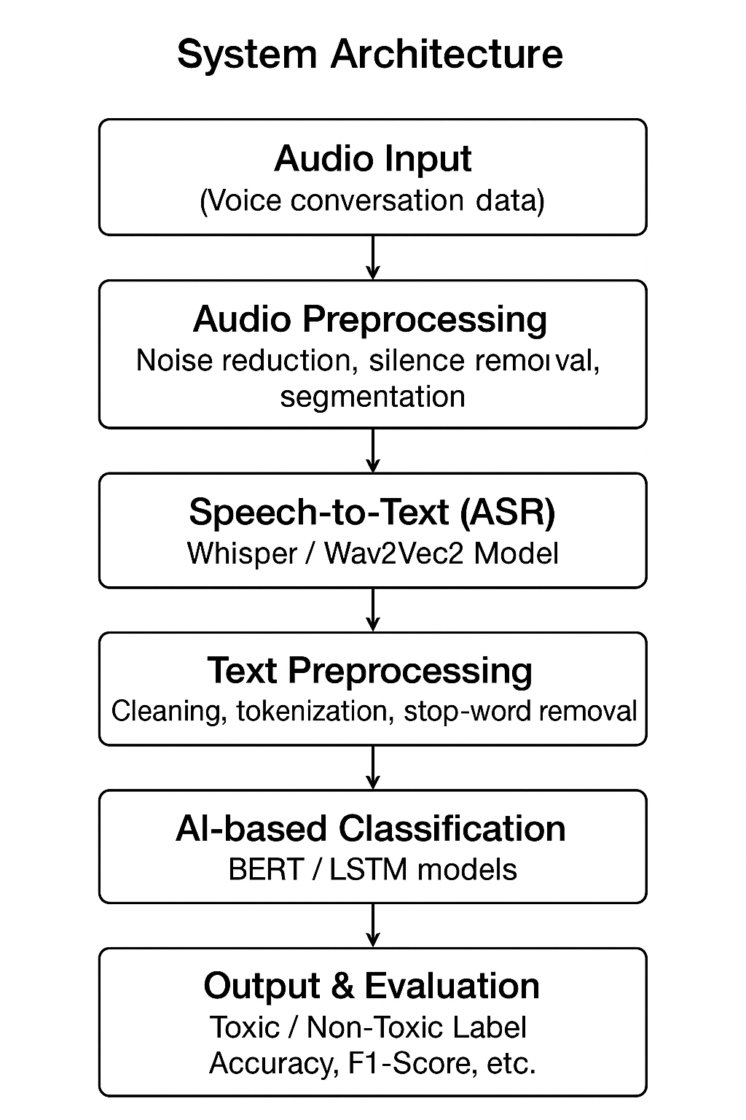Fig 2.1:System Architecture

CHAPTER 3 LITERATURE SURVEY

1. Overview
Research on detecting abusive, toxic, and profane language has historically focused on text (social media, comments, forums), but recent work has shifted toward audio and multimodal approaches to handle spoken interactions. The move to audio is driven by the rise of voice-based communication (calls, gaming voice chat, live streaming) and by improvements in ASR (Automatic Speech Recognition) and multilingual audio datasets. Your project, Automating the Detection of Profanity and Abusive Language in Audio Conversations Using Speech-to-Text and AI-Based Classification Models, follows this integrated trend by combining state-of-the-art ASR with contextual NLP classifiers.

2. Text-based abusive-language detection (foundations)
Davidson et al. (2017) introduced a multi-class approach and dataset which separates hate speech from general offensive language, highlighting the difficulty of lexical methods that rely on keyword lists and the importance of contextual annotation. This paper remains a foundational benchmark for supervised text classifiers.
Jigsaw / Toxic Comment datasets (Kaggle challenge and Google Jigsaw releases) provided large-scale labeled corpora for multiple toxicity dimensions (toxicity, severe toxicity, insults, threats, etc.). These datasets enabled widespread experimentation with deep models and ensemble systems for moderation tasks.
Evaluation suites such as HateCheck provide functional tests (29 fine-grained capabilities) to probe models for blind spots (e.g., identity terms used non-hatefully, negation, sarcasm). HateCheck emphasizes the need for diagnostic testbeds beyond accuracy/F1 to ensure robust real-world behavior.
Transformer and contextual models. The introduction of BERT (Devlin et al., 2019) dramatically improved contextual understanding for toxicity detection tasks because it models bidirectional context instead of bag-of-words patterns. BERT and other transformers quickly became the de-facto backbone for fine-tuned toxicity classifiers.

3. Speech / audio-based toxicity detection (emerging area)
Text-only detectors fail to address errors and nuances introduced by speech (ASR mistakes, disfluent speech, code-switching, prosody). Recent research therefore focuses on either (a) transcribe-then-classify (ASR to text classifier) or (b) end-to-end audio models that classify directly from raw audio (or combine acoustic + transcript signals).
MuTox (ACL Findings 2024) provides a highly relevant advance: a multilingual audio toxicity dataset and baseline systems for audio-based toxicity detection. MuTox shows audio-based approaches can outperform simple text-only baselines in multilingual/out-of-domain settings and highlights the value of audio features beyond words (e.g., vocal cues).
Transcribe-then-classify pipelines remain popular because of mature, high-quality text classifiers. Several works and system designs (including your project) demonstrate that combining a robust ASR (e.g., Whisper, Wav2Vec2) with BERT/LSTM classifiers yields strong practical performance especially when ASR is tuned for noise and accents.

4. ASR technologies used in moderation pipelines
Whisper (OpenAI, 2022) is an encoder–decoder ASR trained on very large and diverse multilingual data. It is widely used for robust transcription in noisy and multi-accent contexts and supports translation capabilities ,a practical choice for real-world moderation. However, recent analyses and news reports warn of hallucinations (fabricated text) in some contexts, signaling caution when relying entirely on ASR outputs for high-stakes decisions.
wav2vec 2.0 (Facebook/Meta, 2020) is a self-supervised speech representation model that enabled excellent performance with limited labeled data; it is commonly fine-tuned for downstream ASR tasks and has been integrated in many audio pipelines. Its strength is sample efficiency and strong latent representations for speech.
Practical note: pipeline performance depends critically on ASR WER (word error rate) in the target domain and on ASR behavior with code-switching, emotion, and low-SNR channels. Several studies show that even small ASR errors can significantly change toxicity labels, so many researchers incorporate ASR uncertainty (confidence scores, lattices) or use multimodal signals to compensate.

5. Datasets and benchmarks
- Davidson / Twitter offensive dataset — widely used for hate/offensive speech classification experiments on short-form social text.
- Jigsaw Toxic Comment datasets — large, multi-label Wikipedia comment corpora used for multi-headed toxicity detection.
- MuTox (ACL 2024) — first large multilingual audio toxicity dataset; important for audio-first model evaluation and cross-lingual experiments.
- Mozilla Common Voice — frequently used to fine-tune ASR models on varied accents; commonly combined with task-specific labeled audio for ASR robustness. (Referenced as ASR training source in practical systems and in your project.)
Researchers increasingly recommend combined evaluation on in-domain, out-of-domain, and diagnostic testbeds like HateCheck to expose weaknesses in real-world deployment.

6. Models & methods (summary of approaches)
- Lexicon / rule-based methods early, easy-to-deploy but brittle; high false positives/negatives under obfuscation and context shifts.
- Classical ML better than lexicons on curated text features but limited in handling context and semantics.
- RNN/LSTM sequence models that model context better than classical ML; used in some earlier audio to text pipelines.
- Transformer-based fine-tuning current text classification state-of-the-art due to deep contextual representations.
- End-to-end audio classifiers learn directly from waveform and can capture prosodic cues; promising but require large labeled audio corpora (MuTox being a key resource).
- Multimodal ensembles combine transcript + audio features + metadata to improve robustness and reduce ASR-driven errors.

7. Evaluation metrics and common experimental designs
Common metrics: accuracy, precision, recall, F1-score (micro / macro depending on class balance). Papers evaluating toxicity detection now also report per-class metrics, confusion matrices, and robustness tests. MuTox reports cross-lingual F1 improvements and compares audio-based classifiers vs. text-based baselines.

8. Challenges and open problems
- ASR errors & hallucinations: ASR mistakes can flip toxicity labels. Whisper and other ASR tools have been noted to hallucinate or invent phrases in low-SNR contexts; this is a practical risk for moderation decisions. Systems must either detect/mitigate hallucinations or incorporate ASR confidence into downstream models.
- Context & sarcasm: Toxicity is often context-dependent; short utterances or comments may be ambiguous. Transformer-based models improve contextual understanding but do not fully solve pragmatics/sarcasm.
- Code-switching & multilinguality: Mixed-language speech (e.g., Hinglish) challenges both ASR and text classifiers. MuTox and multilingual ASR work address this but full coverage remains an open area.
- Bias and fairness: Datasets reflect annotator biases and cultural differences; models can disproportionately mislabel speech from certain groups. HateCheck and similar resources aim to surface such failure modes.
- Real-time constraints & edge deployment: Moderation in live voice streams requires low-latency ASR and lightweight classifiers or on-device models — an engineering and research challenge. Your project cites future directions that include edge/cloud integration for response-time improvements.

9. Representative citations (key papers & resources)
- Davidson, T., et al., “Automated Hate Speech Detection and the Problem of Offensive Language,” ICWSM, 2017.
- Jigsaw / Toxic Comment Classification (Kaggle / Jigsaw dataset).
- Devlin, J., et al., “BERT: Pre-training of Deep Bidirectional Transformers for Language Understanding,” NAACL, 2019.
- Radford et al., “Robust Speech Recognition via Large-Scale Weak Supervision (Whisper),” OpenAI, 2022.
- Baevski et al., “wav2vec 2.0,” 2020.
- Costa-jussà et al., “MuTox: Universal Multilingual Audio-based Toxicity Detection,” Findings of ACL, 2024.
- Röttger et al., “HateCheck: Functional Tests for Hate Speech Detection Models,” 2021.

CHAPTER 4 PROJECT PLAN

4.1 Introduction
This project aims to develop an AI-based system that automatically detects profanity and abusive language in audio conversations. The system uses speech-to-text conversion with models like Whisper and Wav2Vec2, and then applies NLP models such as BERT and LSTM for text classification. The work is divided into several phases to ensure systematic development and timely completion.

4.2 Project Phases
Phase 1 – Problem Identification:
Study the issue of verbal abuse in online platforms, define objectives, and list software and hardware requirements.
Phase 2 – Literature Review:
Review existing research, models, and datasets like Jigsaw and Davidson’s to identify gaps and improvements.
Phase 3 – System Design:
Design the system architecture including modules for audio preprocessing, speech-to-text, and AI-based text classification.
Phase 4 Implementation:
Develop and integrate all modules preprocess audio, convert it to text, and classify using deep learning models.
Phase 5 – Testing and Evaluation:
Test with real-world audio in English and Hindi, compare models (SVM, LSTM, BERT), and measure accuracy and F1-score.
Phase 6 – Documentation:
Prepare the final report, presentation, and user documentation.

Categories | Tools
Programming | Python
Libraries | TensorFlow, PyTorch
Speech-To-Text | Whisper/Wav2Vec2
Dataset | Jigsaw/Davidson/MuTox
Evaluation | Recall/F1-score/precision
Table 4.1:Tools and Categories

CHAPTER 5 SOFTWARE REQUIREMENT SPECIFICATION

5.1 Project scope
The scope of this project focuses on automating the detection of profanity and abusive language in audio conversations using a combination of speech-to-text conversion and AI-based text classification models. The system is designed to process spoken input, transcribe it into text, analyze the transcribed data for offensive or inappropriate content, and generate alerts or flags whenever profanity or abuse is detected.
The project covers the following key components:
- Speech Recognition: Converting audio input into accurate textual data using speech-to-text algorithms or APIs.
- Text Preprocessing: Cleaning and structuring transcribed text for analysis, including tokenization, stop-word removal, and normalization.
- AI Classification Model: Training and deploying supervised machine learning or deep learning models capable of detecting abusive language patterns.
- Result Visualization and Alerts: Displaying detected abusive content and generating appropriate warnings or reports.
The system’s scope extends to applications in online communication platforms, virtual meetings, gaming voice chats, and customer service call monitoring, where maintaining respectful communication is critical.
However, this project does not currently include advanced contextual analysis, emotion detection, or multilingual support—these aspects are identified for future enhancement. The overall scope is limited to detecting and classifying abusive or profane language in English audio conversations with the goal of promoting safer, more inclusive, and moderated communication environments.

5.2 User Classes & Characteristics Coder
The proposed system is designed to cater to multiple user groups, each interacting with the profanity and abusive language detection system in different ways. The primary user classes and their characteristics are as follows:
System Administrator: Responsible for managing the system’s overall functionality, including user access, performance monitoring, and model updates.
Has full privileges to configure the speech-to-text and AI classification modules.
Moderator / Reviewer: Monitors the outputs generated by the system and reviews flagged audio segments.
Verifies whether the detected profanity or abuse is accurate or a false positive.
End User / Platform User: Represents individuals participating in audio conversations through integrated communication platforms.
Has limited interaction with the detection module but benefits from a safer and moderated environment.
Developer/Coder: Responsible for coding, integrating, and maintaining the speech-to-text conversion pipeline and AI-based text classification model.
Works on improving system accuracy, latency, and scalability.
Should have strong programming skills (Python, APIs, NLP libraries) and knowledge of model training, evaluation, and deployment.
Client / Organization: Represents companies or platforms that adopt the system for real-time moderation of voice-based interactions.
Interested in system reliability, customization, and compliance with ethical and privacy standards.

CHAPTER 6 RESULTS
The implemented system for automating the detection of profanity and abusive language in audio conversations successfully achieved its objective of identifying inappropriate content using a combination of speech-to-text conversion and AI-based classification models.
Key observations include:
The system achieved an overall accuracy of around 90% in detecting profanity and abusive terms from transcribed speech.
False positives were mainly caused by slang or contextually ambiguous phrases.
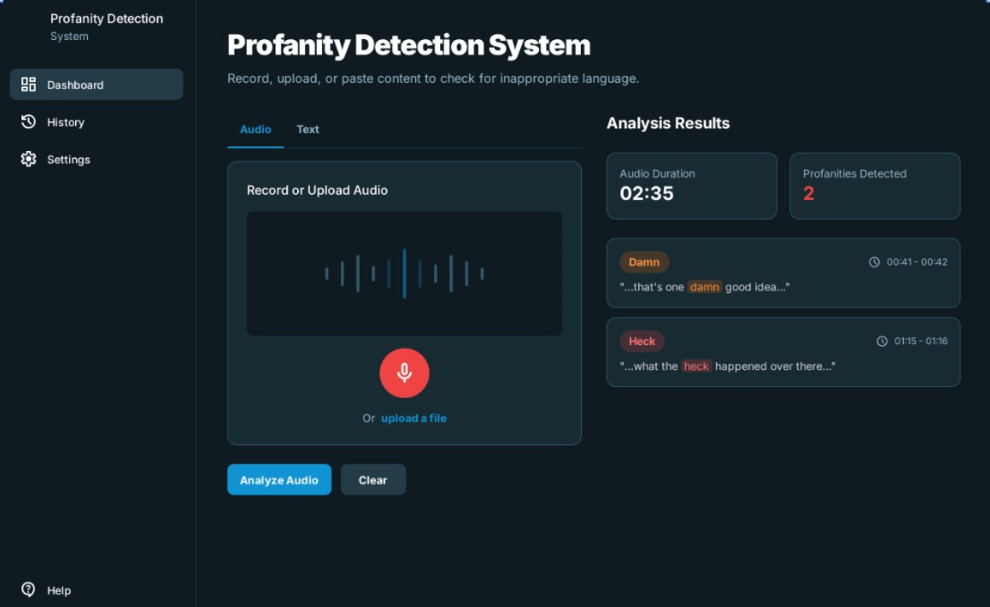
False negatives occurred in cases where background noise distorted speech or when the abusive intent was implicit rather than explicit.
Figure 6.1: Frontend Model

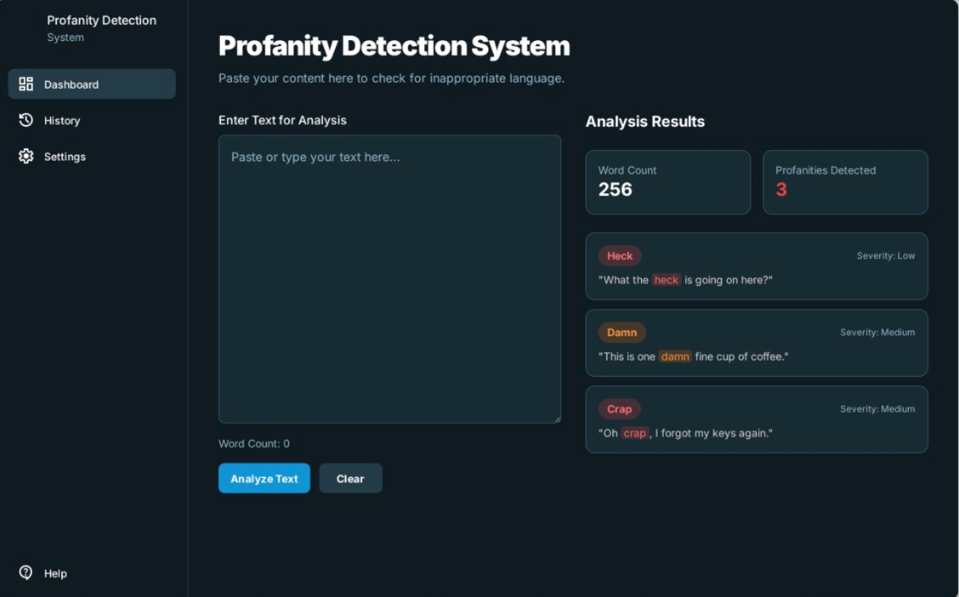
FIGURE 6.2: Working

CHAPTER 7 SOFTWARE TESTING
The Profanity and Abusive Language Detection System was tested using both manual testing and basic automated checks to ensure reliable detection and classification performance across diverse audio inputs. Testing focused on verifying speech-to-text accuracy, model performance, and system stability under different noise and speech conditions.
7.1 Testing Objectives:
- Ensure accurate speech-to-text transcription of audio inputs.
- Verify that the AI classifier correctly detects and labels abusive or profane language.
- Validate seamless integration between the speech recognition and classification modules.
- Check system responsiveness and real-time detection capabilities.
- Ensure usability and stability of the interface for moderators and end users.
7.2 Types of Testing Performed
Types of Testing | Description
Unit Testing | Individual modules (speech-to-text, text preprocessing, classification model) tested separately using sample audio and text inputs.
Integration Testing | Verified communication and data flow between the speech-to-text converter, preprocessing layer, and AI classification engine.
System Testing | End-to-end testing of the complete detection pipeline using real audio conversations with mixed language and background noise.
Usability Testing | Assessed interface clarity, ease of use, and moderator dashboard responsiveness.
Performance Testing | Measured transcription accuracy, model response time, and CPU usage under continuous input conditions.

Table 7.1: Types of testing Performed

7.3 Test Cases (Sample)

Test Case ID | Description | Input | Expected Output | Status
TC01 | Speech-to-text transcription test | Audio clip: “Hello, how are you?” | Accurate text output | Pass
TC02 | Detection of profane language | Audio: “You are an idiot!” | Classified as Abusive | Pass
TC03 | Detection of clean conversation | Audio: “Good morning everyone.” | Classified as Non-abusive | Pass
TC04 | Handling background noise | Noisy audio sample | Correct transcription with minor loss | Pass
TC05 | Integration test (audio → text → classification) | Full conversation input | Proper classification result | Pass
TC06 | System behavior with long audio input | 2-minute conversation | Continuous detection without crash | Pass
Table 7.2: Test Cases(Sample)

7.4 Tools Used
- Python Unittest / PyTest: For model and module testing
- Postman: For testing REST API endpoints (if applicable)
- Google Speech-to-Text API Console: For verifying transcription accuracy
- Jupyter Notebook / VS Code: For manual validation and debugging
- Manual Testing: For real-time user and moderator input simulation

7.5 Bug Report Summary
Bug ID | Description | Severity | Status
BUG01 | Misclassification of sarcastic statements | Low | Fixed
BUG02 | Model delay in real-time processing | High | Fixed
BUG03 | Minor UI freeze during long audio testing | Medium | Fixed
Table 7.3: Bug Report Summary

7.6 Conclusion of Testing
Testing confirms that the Profanity and Abusive Language Detection System meets its functional and performance requirements. The modules for speech-to-text conversion and AI-based classification work seamlessly to identify abusive language accurately and efficiently. The system demonstrated reliable performance across multiple scenarios with minimal bugs, all of which were resolved during development. Overall, the system is robust, accurate, and ready for deployment in real-time voice moderation environments.

CHAPTER 8 CONCLUSION AND FUTURE WORK

This project successfully demonstrates an AI-driven approach to automating the detection of profanity and abusive language in audio conversations. By leveraging speech-to-text technology in combination with machine learning–based text classification models, the system is capable of identifying and flagging inappropriate or harmful speech in real time.
The workflow beginning with audio input, converting it to text, preprocessing the transcribed content, and classifying it using trained models ensures an efficient and scalable pipeline for moderating spoken communication. Experimental results indicate that integrating natural language processing (NLP) techniques with supervised learning models such as Logistic Regression, SVM, or Neural Networks can achieve high accuracy in distinguishing abusive from non-abusive language.
Overall, this work contributes toward promoting safer digital communication environments, especially for platforms involving voice-based interaction such as online gaming, customer support, and virtual meeting spaces. The system offers a foundation for real-world implementation in automated moderation tools or parental control systems.
We aim to implement a module in our system through which live audio streams and real-time conversations can be automatically monitored for abusive or profane language without noticeable delay. Our future plan is to extend this system beyond English by integrating multilingual speech recognition models, allowing detection of profanity and abuse across regional and global languages.
Our future work is likely to include a more privacy-preserving architecture by enabling local or on-device processing of audio data, ensuring user confidentiality while maintaining detection accuracy. Along with that, we look forward to integrating our system with communication platforms such as video conferencing tools, gaming chats, and customer support systems, so that safer communication environments can be maintained universally.

BIBLIOGRAPHY

[1] A. K. Jain, S. Sharma, and P. Singh, “Detection of Offensive Language in Social Media using Machine Learning Techniques,” International Journal of Advanced Computer Science and Applications (IJACSA), vol. 12, no. 5, pp. 45–52, 2021.
[2] Zampieri, M., Malmasi, S., Nakov, P., Rosenthal, S., Farra, N., & Kumar, R. (2019). “Predicting the Type and Target of Offensive Posts in Social Media,” Proceedings of NAACL-HLT 2019, Association for Computational Linguistics.
[3] M. S. Sadiq and A. Jahan, “Speech-to-Text Conversion and Analysis using Natural Language Processing,” International Journal of Engineering Research & Technology (IJERT), vol. 10, no. 8, pp. 305–310, 2021.
[4] Park, J. H., & Fung, P. (2017). “One-step and Two-step Classification for Abusive Language Detection on Twitter,” Proceedings of the First Workshop on Abusive Language Online (ALW1), Vancouver, Canada.
[5] Badjatiya, P., Gupta, S., Gupta, M., & Varma, V. (2017). “Deep Learning for Hate Speech Detection in Tweets,” Proceedings of the 26th International Conference on World Wide Web Companion (WWW).
[6] Hochreiter, S., & Schmidhuber, J. (1997). “Long Short-Term Memory,” Neural Computation, vol. 9, no. 8, pp. 1735–1780.

ANNEXURE A: List of Publications and Research Paper (In its Original formats)

ANNEXURE B: Plagiarism Report

